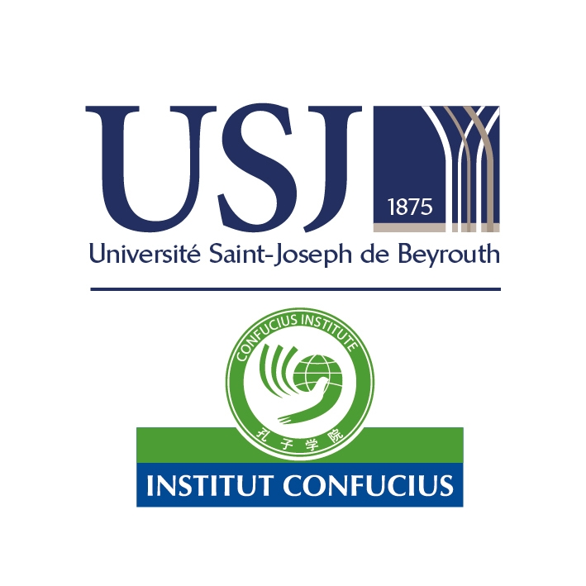

**2024-2025学年黎巴嫩圣约瑟夫大学**

**孔子学院工作计划**

**Work Plan CIUSJ**

**Academic Year 2024-2025**

**2024年9月**

**2024-2025学年黎巴嫩圣约瑟夫大学孔子学院工作计划**

2024-2025学年，黎巴嫩圣约瑟夫大学孔子学院继续坚持以中文教学为中心，同时开展多种文化交流活动，推动沈阳师范大学和圣约瑟夫大学在学科发展和人才培养方面开展合作，开创孔子学院可持续高质量发展新局面。

一、推进中文教学，促进孔子学院可持续发展

中文教学是孔子学院的核心工作。圣约瑟夫大学孔子学院会继续秉持“扎根本土，融入当地，服务需求”的办学理念，推动孔子学院朝本土化方向发展。除了孔子学院常规中文课程外，孔院还会继续与当地中小学合作，推动中文教学走进黎巴嫩基础教育体系，同时积极寻求与黎巴嫩大学汉语专业合作，推动沈阳师范大学与黎巴嫩大学联合培养汉语专业人才。

二、继续做好线上线下教学，提升中文教学质量

后疫情时代，线上线下融合式教学已经成为教学常态，面对新的教育形态，圣约瑟夫大学孔子学院将充分利用网络资源和数字化服务平台，开展在线中文教育，打破时空限制，推动新形势下国际中文教育驶入快车道。教师需更新教学理念，树立终身学习的理念，积极学习新知识、新技术，不断自我更新，善于运用新技术重构教学内容、创新教学方法，引导学生主动参与学习、自主建构知识，应对新时代需求。将现代教育技术与课堂教学深度融合，实现线上线下融会贯通，确保实现教学目标。

在孔子学院发展进程中，我们愈发深刻地感受到，个性化、差异化、多样化的中文学习需求与日俱增。随着中文学习者主体和学习需求的多元化，传统的教学内容和教学方式也遇到挑战，这对教师提出了更高的要求。孔子学院应一直将学员的需求放在第一位，采用灵活的教学方式，最大限度地满足不同学习者之需，只有这样，才能切实提高国际中文教育效果。

三、加强师资队伍建设，培养高质量中文人才

教师队伍是孔子学院建设发展的根本。打造一支有信念、有能力、有情怀的孔子学院教师队伍，对于孔子学院在战略发展机遇期实现更大的作为具有决定性影响。孔子学院中文教师应在专业知识、教学能力、教育学和心理学知识、中国文化素养、跨文化交际能力等方面提升自己，为国际中文教育事业发展培养高质量的人才。

四、开展语言文化交流活动，促进中黎人文交流

充分发挥孔子学院综合文化交流平台的独特优势，不断深化中黎人文交流，拓宽合作领域，开展丰富多彩、不同层次的文化交流活动，丰富中阿文明交流互鉴的内容和形式。

五、发挥中外合作双方主体作用，推动孔子学院可持续高质量发展

充分发挥沈阳师范大学和圣约瑟夫大学合作主体支撑作用，尤其是在制定发展规划、建设师资队伍、搭建科研平台、共享科研成果、按需开展项目、丰富合作层次、开展相关研究与交流活动等方面发挥双方的办学主体作用，促进孔子学院可持续高质量发展。

六、落实语合中心和合作双方重点项目

（一）中文教学项目

1. 中文教学

2. 中文水平考试

3. 国际中文教师奖学金

4. “汉语桥”世界大学生中文比赛

5. 中文教学研讨会

6. 推进圣约瑟夫大学翻译学院的翻译项目

7. 推动与黎巴嫩大学语言中心合作，联合培养汉语专业本科和研究生人才培养。

（二）文化交流项目

1. “汉语桥”夏令营

2. “汉语桥”教育工作者访华团

3. 中国美食

4. 孔子学院日

5. 中国概况系列讲座

6. 与维和部队合作，为联黎司令部开展汉语培训

7. 中国文化沙龙

在沈阳师范大学、黎巴嫩圣约瑟夫大学、教育部中外语言交流合作中心和中国国际中文教育基金会的大力支持下，孔子学院在各方面均取得了显著成绩，2024-2025学年，孔子学院将继续以拓展中文教学，开展文化活动为中心，加强内涵和质量建设，为促进中黎各领域交流合作做出新的贡献。

黎巴嫩圣约瑟夫大学孔子学院

2024年9月

**Work Plan CIU-SJ**

**(Academic Year 2024-2025)**

In the academic year 2024-2025, Confucius Institute at St. Joseph's University in Lebanon will continue to focus on Chinese language teaching and carry out various cultural activities, promoting cooperation between Shenyang Normal University and St. Joseph University in disciplinary development and talent cultivation, and making new progresses for the sustainable and high-quality development of the Confucius Institute.

I. Promoting Chinese Language Teaching to achieve the Sustainable Development of Confucius Institute

Chinese teaching is the core work of Confucius Institutes. Confucius Institute at Saint Joseph's University will continue to adhere to the educational philosophy of "rooted in the local area, integrated into the local area, and serving the local needs", and promote the development of Confucius Institute towards localization. In addition to the regular Chinese courses offered by Confucius Institute, Confucius Institute will continue to collaborate with local primary and secondary schools to promote the integration of Chinese language teaching into the Lebanese basic educational system. At the same time, it will actively seek cooperation with the language Center at Lebanese university and promote the joint training of Chinese language professionals between Shenyang Normal University and Lebanese University.

II. Continue the online and offline teaching to improve the quality of Chinese language education

In the post-pandemic era, integrated online and offline teaching has become the norm. In the face of new forms of education, Confucius Institute of Saint Joseph University fully utilizes network resources and digital service platforms to carry out online Chinese teaching, breaking time and space limits, and driving international Chinese education into the fast lane under the new situation. Teachers need to update their teaching philosophy, establish the concept of lifelong learning, actively learn new knowledge and technologies, constantly update themselves, be good at using new technologies to reconstruct teaching content and innovate teaching methods, guide students to actively participate in learning, independently construct knowledge, and respond to the needs of the new era.

In the development process of Confucius Institutes, we have become increasingly aware of the increasing demand for personalized, differentiated, and diversified Chinese language learning. With the diversification of the learners and learning needs of Chinese learners, traditional teaching content and methods are faced with increasing challenges, which puts higher demands on teachers. Confucius Institutes should always prioritize the needs of students and adopt flexible teaching methods to meet different learning needs to the greatest extent possible. Only in this way can the effectiveness of international Chinese language education be improved.

III. Strengthen the team work of Chinese teachers to cultivate high-quality Chinese talents

The teaching staff is the fundamental foundation for the construction and development of Confucius Institutes. Building a confident, capable, and compassionate faculty of Confucius Institutes has a decisive impact on achieving greater success during the strategic development opportunity period. Chinese language teachers at Confucius Institutes should enhance their professional knowledge, teaching abilities, educational and psychological knowledge, Chinese cultural literacy, cross-cultural communication skills, and cultivate high-quality talents for the development of international Chinese language education.

IV. Carry out language and cultural activities to promote cultural exchanges between China and Lebanon

By fully taking the unique advantages of the Confucius Institute's comprehensive cultural exchange platform, CIUSJ will continuously deepen cultural exchanges between China and Lebanon, expand cooperation areas, carry out diverse cultural activities at different levels, and enrich the content and forms of cultural exchanges and mutual learning between China and Lebanon.

V. Give full play to the main role of both Chinese and foreign cooperation parties, and promote the sustainable and high-quality development of Confucius Institutes

Relying on the support of cooperative parties of Shenyang Normal University and St. Joseph's University, especially in the area of formulating development plans, building teaching staff, building research platforms, sharing research results, conducting projects as needed, enriching cooperation content, and conducting related research and exchange activities, CIUSJ will surely achieve sustainable and high-quality development in the future.

VI. Implement key projects of the Language Cooperation Center and cooperative parties

1. Chinese Teaching Program

(1) Chinese language teaching

(2) Chinese proficiency test

(3) International Chinese Teacher Scholarship

(4) "Chinese Bridge" Chinese Proficiency Competition of College Students

(5) Chinese Teaching Seminar

(6) Promote the translation diploma program of the School of Translation at St. Joseph's University

(7) Promote cooperation with the Language Center of the University of Lebanon to jointly cultivate undergraduate and graduate talents in the field of Chinese language.

2. Cultural exchange projects

(1) "Chinese Bridge" summer camp

(2) “Chinese Bridge” educators’ tour to China

(3) Chinese cuisine program

(4) Confucius Institute Day

(5) Series lecture on China panarama

(6) Collaborate with Chinese peacekeeping forces to conduct Chinese language training for the UNIFIL

(7) Chinese culture salon

With the strong support of Shenyang Normal University and St. Joseph's University of Lebanon, the Sino Foreign Language Exchange and Cooperation Center of the Ministry of Education, and the International Chinese Education Foundation, the Confucius Institute has achieved remarkable achievements in all aspects in the academic year 2023-2024. In the academic year 2024-2025, Confucius Institute USJ will continue to focus on expanding Chinese language teaching and carrying out cultural activities, strengthening quality construction, and making new contributions to promote exchanges and cooperation in various fields between China and Lebanon.

Confucius Institute, USJ

Sep, 2024